Please use this form to submit comments on the third draft of the Frequency Response SAR. Comments must be submitted by March 9, 2007. You may submit the completed form by e-mail to sarcomm@nerc.com with the words “FR SAR Draft 3” in the subject line. If you have questions please contact Maureen Long at maureen.long@nerc.net or by telephone at 813-468-5998.

Individual Commenter Information
(Complete this page for comments from one organization or individual.)
Name:
Organization:
Telephone:
E-mail:
NERC Region |  | Registered Ballot Body Segment
ERCOT  FRCC  MRO  NPCC  RFC  SERC  SPP  WECC  NA – Not Applicable |  | 1 — Transmission Owners
 |  | 2 — RTOs, ISOs
 |  | 3 — Load-serving Entities
 |  | 4 — Transmission-dependent Utilities
 |  | 5 — Electric Generators
 |  | 6 — Electricity Brokers, Aggregators, and Marketers
 |  | 7 — Large Electricity End Users
 |  | 8 — Small Electricity End Users
 |  | 9 — Federal, State, Provincial Regulatory or other Government Entities
 |  | 10 — Regional Reliability Organizations, Regional Entities

Group Comments (Complete this page if comments are from a group.)
Group Name:
Lead Contact:
Contact Organization:
Contact Segment:
Contact Telephone:
Contact E-mail:
Additional Member Name | Additional Member Organization | Region* | Segment*
*If more than one Region or Segment applies, indicate the best fit for the purpose of these comments. Regional acronyms and segment numbers are shown on prior page.

Background Information:
The original SAR on Frequency Response was submitted in large part due to a study that showed a 10+% decline in Eastern Interconnection Frequency Response over a 5-year period, when response should be increasing over time as the Interconnection grows. Other Interconnections were observing similar declines. The drafting team posted a white paper along with the SAR to outline the need for a standard.

The NERC Resources Subcommittee recently updated their estimate of Eastern Interconnection Frequency Response and found it still trending downward. Response in 2006 was on the order of 2,800 MW/0.1Hz (compared to 3,750 MW/0.1Hz in 1994). Frequency Response for larger events (greater than 35 mHz) in 2006 may be as low as 2,600 MW/0.1Hz. Below is an independently calculated estimate of the trend in Eastern Interconnection Frequency Response provided by the New York ISO. Note: Response is stated in engineering terms (MW/mHz) as opposed to the traditional MW/01.Hz.

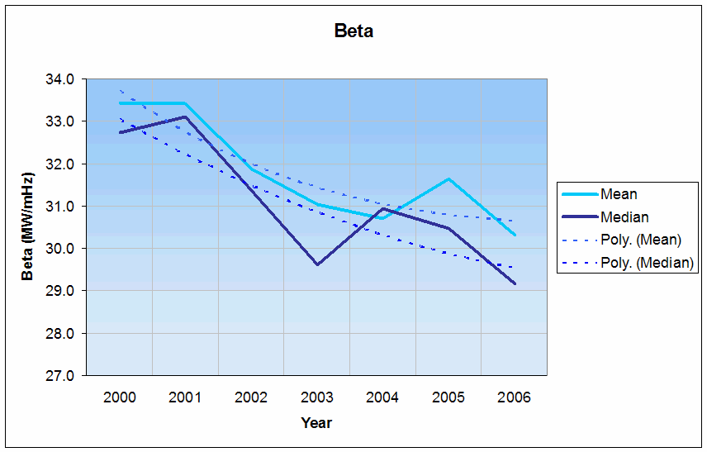

The proposed Frequency Response standard (FRS) is a technical standard. Technical standards are described in the Reliability Standards Development Procedure. The FRS is not proposed to be a performance standard and does not propose a minimum Frequency Response, below which penalties are applied.

Industry commenters agreed there is a reliability need for the FRS. Comments varied on the technical details of the standard. Because of the divergent views on the details of the FRS SAR, the NERC Standards Committee (SC) directed the SAR drafting team to revise the SAR to focus only on the data collection needed to support the development of accurate models of Frequency Response in North America.

The SAR drafting team has tried to meet the Standards Committee’s directive with this third version of the SAR.

The Version 3 of the Frequency Response SAR represents the changes requested by the NERC Standards Committee, while still meeting the June 2006 direction of the NERC Operating Committee. Specifically, the Operating Committee endorsed developing a Frequency Response standard that includes the following goals and objectives:
- Improving Interconnection Frequency Response event cataloging and benchmarking.
- Calculating balancing authority Frequency Response and requiring balancing authorities to analyze those cases where the response is significantly below the norm.
- Establishing time limits to complete the analyses.
- Tabulating non-responsive generators.
- Measuring generator response (those units on line).
- Including regional participation and review.

This revised SAR was reviewed and supported by the NERC Resources Subcommittee on December 4, 2006. The major changes between Draft 2 and Draft 3 include:
- Clarification on the role of the Load-serving Entity and Generator Operator.
- Inclusion of the applicability of Reliability Principles 3, 5, and 6.
- Reduced the scope to address only the collection of data needed to model Frequency Response in North America.
- Clarified that the data collected to model frequency response over a period of up to 5 minutes per event to help identify the window of time where frequency response appears to be masked by AGC action.
Note that because the changes to the SAR were quite significant, no redline showing the changes from Version 2 to Version 3 will be posted.

Please review the revised SAR and then answer the questions on the following page. Comments must be submitted by March 9, 2007. You may submit the completed form by e-mail to sarcomm@nerc.com with the words “FR SAR Draft 3” in the subject line.
You do not have to answer all questions. Enter All Comments in Simple Text Format.
Insert a “check” mark in the appropriate boxes by double-clicking the gray areas.

- Do you agree with the reduced scope of this SAR — focusing only on the data collection needed to support the development of accurate models of Frequency Response in North America?
Yes
No
Comments:

- The proposed standard would have requirements for the following functional entities: Reliability Coordinator, Balancing Authority, Generator Owner, Generator Operator, and Load-serving Entity. Do you agree that these are the right functional entities for the proposed standard?
Yes
No
Comments:

- The SAR drafting team modified the SAR to clarify that data will be collected to model up to 5 minutes of frequency response. This should help identify the window of time where frequency response appears to be masked by AGC action. Do you agree with this clarification?
Yes
No
Comments:

- Should a field trial be initiated, whereby a set of events for each Interconnection is posted throughout the year, to be used by BAs to calculate their 2007 Frequency Response?
Yes
No
Comments:

- Please provide any other comments (that you have not already provided in response to the first three questions on this form) that you have on the revised SAR.
Comments:

